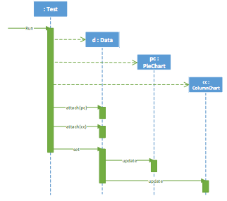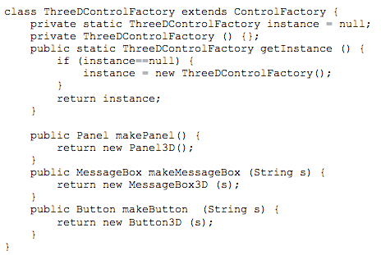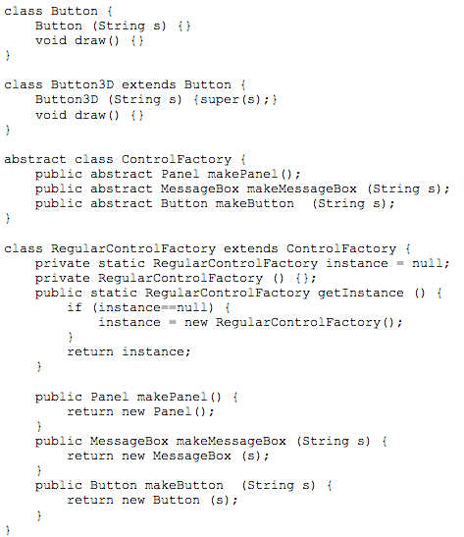

Draw a UML sequence Diagram for the data chart example of Observer design pattern

* **13 Design Patterns:**
* GoF design patterns
  + Singleton, Abstract Factory
  + Adapter, Façade, Composite
* GRASP
  + Information Expert
  + Creator
  + Low Coupling
  + High Cohesion
  + Controller
  + Pure Fabrication
  + Polymorphism
  + Indirection

class Data {

private List<Observer> observers =

new ArrayList<Observer>();

public void attach(Observer o) {

observers.add (o);

}

public void deattach(Observer o) {

observers.remove (o);

}

…

}

abstract class Observer {

abstract void update (Data d);

}

class PieChart extends Observer {

public void update (Data d) {…}

}

class ColumnChart extends Observer {

public void update (Data d) {…}

}

class Data {

int a=50, b=30, c=20;

void set (int a, int b, int c) {

this.a = a; this.b = b; this.c = c;

**//notify all observers**

**Iterator<Observer> i = observers.iterator();**

**while (i.hasNext()) {**

**Observer o = i.next();**

**o.update(this);**

**}**

}

}